**Vivekanand Education Society’s** 

**Institute of Technology**

**(Affiliated to University of Mumbai, Approved by AICTE & Recognized by Govt. of Maharashtra)**

**Department of Information Technology**

A.Y. 22-23

MAD & PWA Lab

Journal

| Experiment No. | 05 |
| --- | --- |
| Experiment  Title. | To apply navigation, routing and gestures in Flutter App |
| Roll No. | 53 |
| Name | SAKSHI SANTOSH PATIL |
| Class | D15B |
| Subject | MAD & PWA Lab |
| Lab Outcome | LO2: Design and Develop interactive Flutter App by using widgets, layouts, gestures and animation |
| Grade: |  |

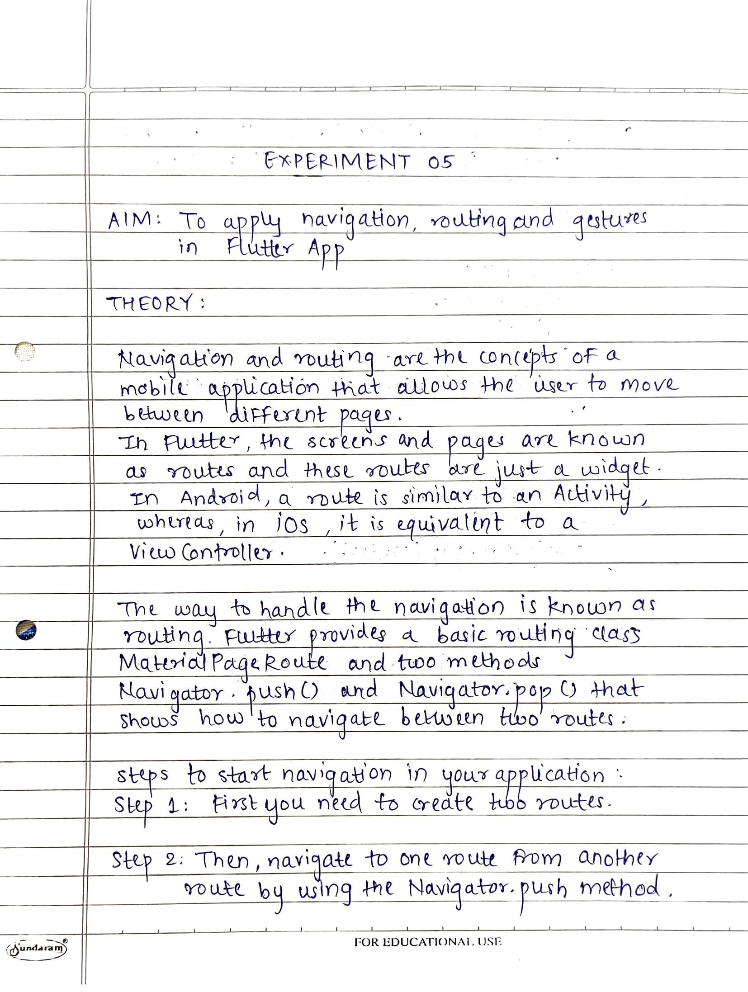

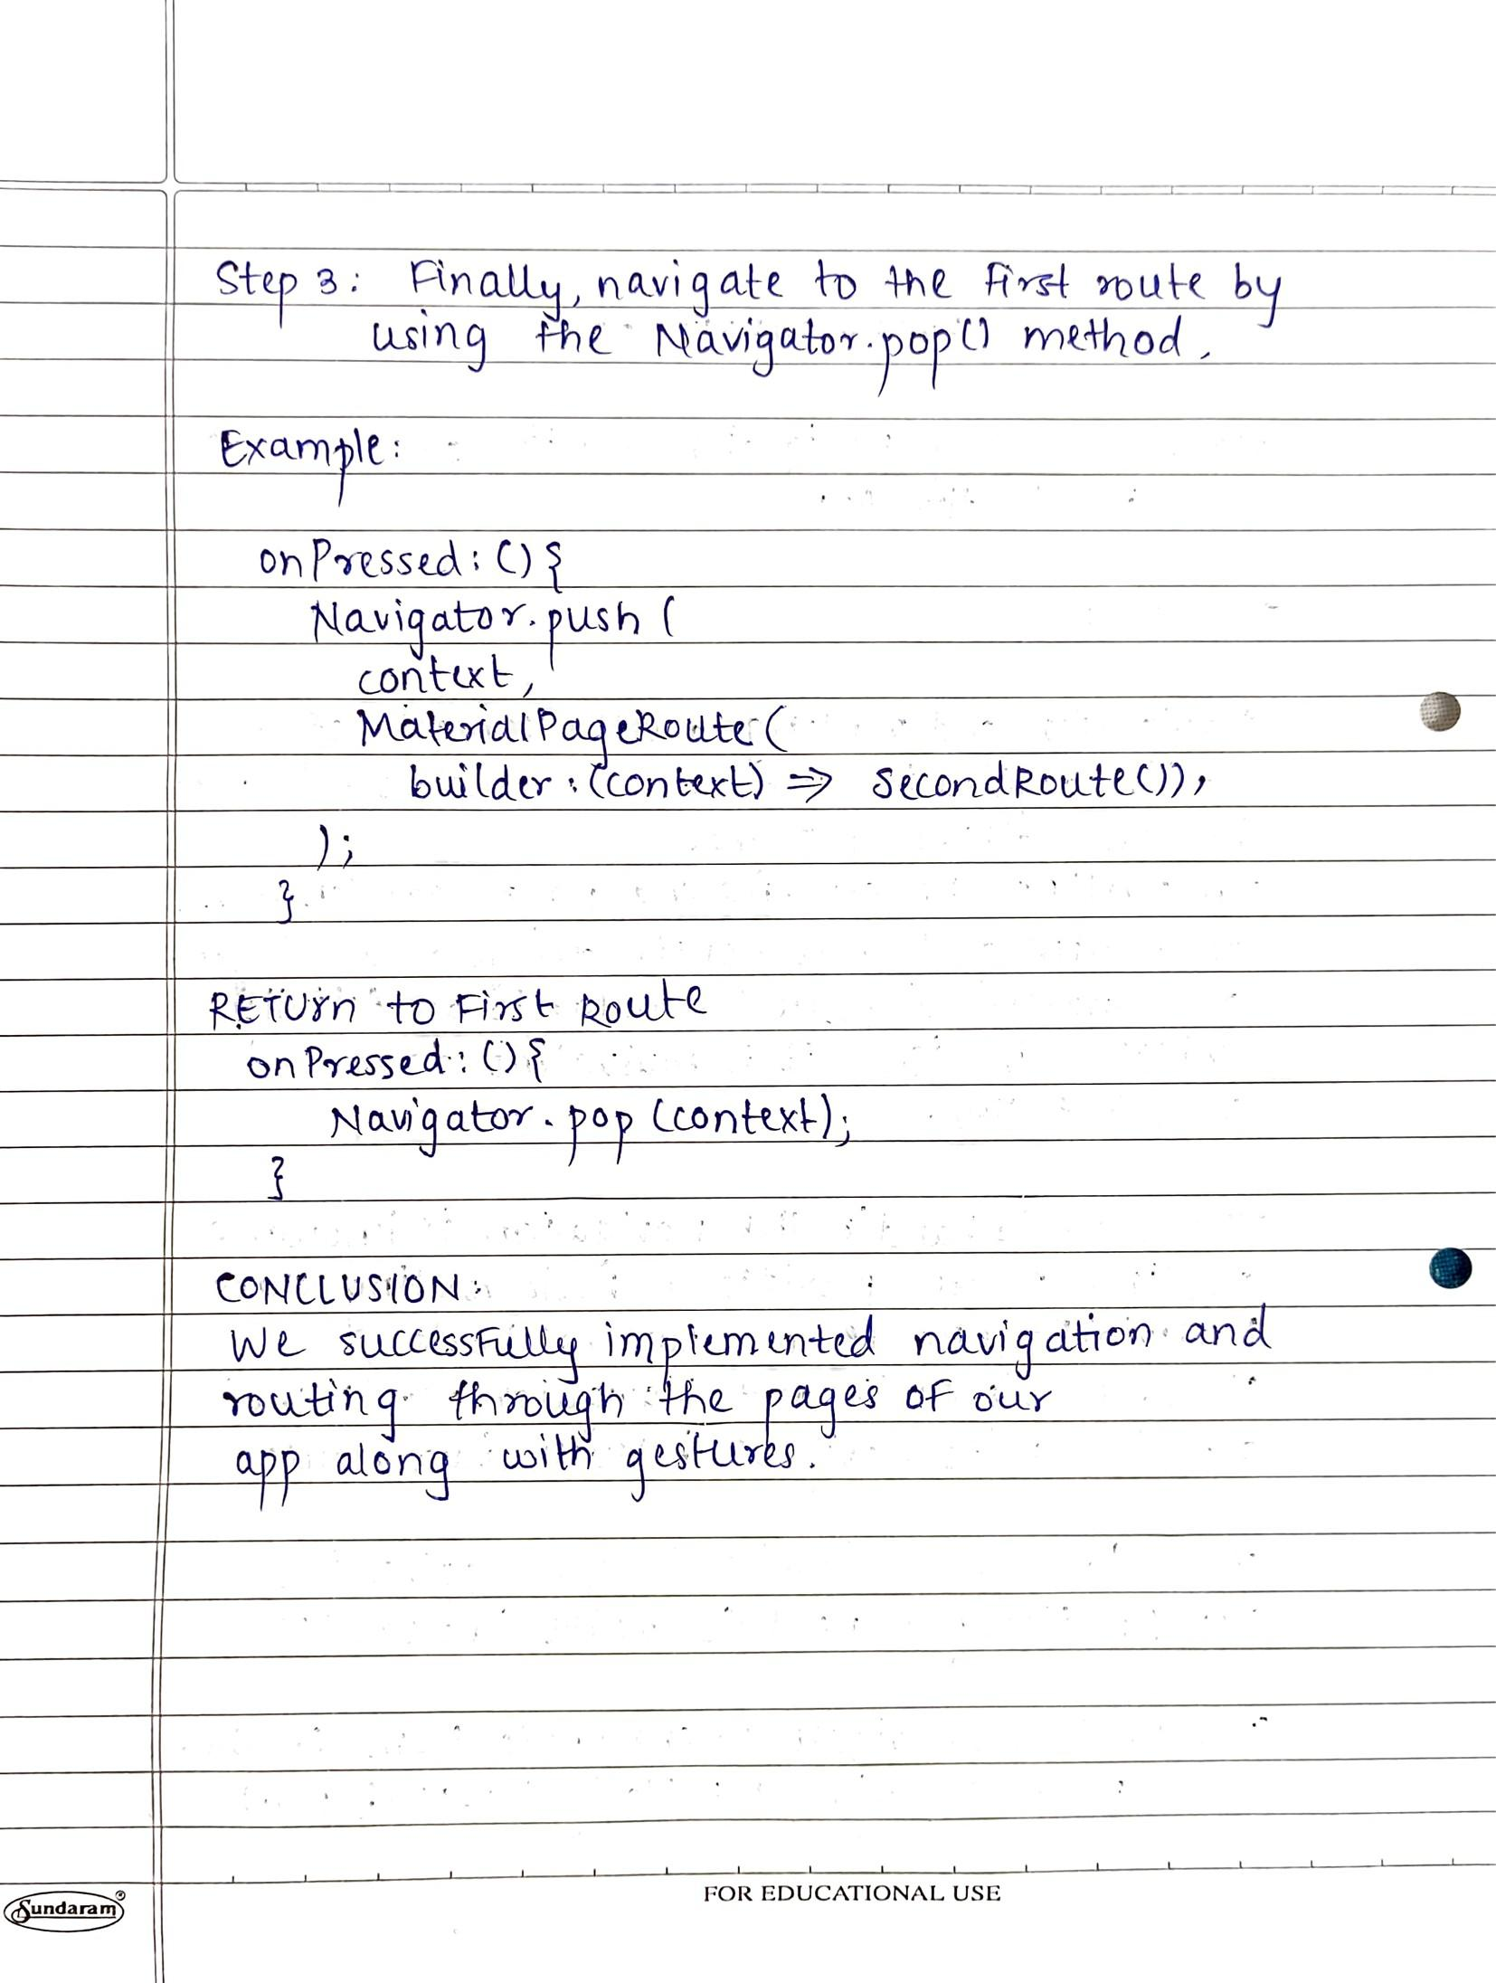

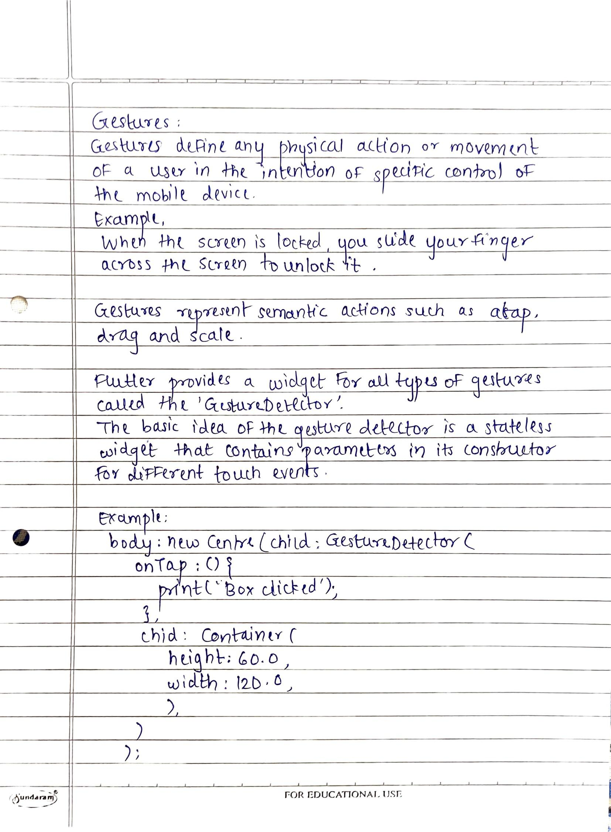

**AIM:** To apply navigation, routing and gestures in Flutter App

**CODE:**

**loginScreen.dart**

import 'package:flutter/material.dart';

import 'package:uber_clone/screens/registrationScreen.dart';

class loginScreen extends StatefulWidget {

const loginScreen({Key? key}) : super(key: key);

@override

State<loginScreen> createState() => _loginScreenState();

}

class _loginScreenState extends State<loginScreen> {

final _formkey = GlobalKey<FormState>();

@override

Widget build(BuildContext context) {

return Form(

key: _formkey,

child: Scaffold(

resizeToAvoidBottomInset : false,

backgroundColor: Colors.white,

body: SingleChildScrollView(

child: Padding(

padding: const EdgeInsets.all(8.0),

child: Column(

children: [

SizedBox(height: 40.0,),

Image(image: AssetImage("images/Uber-logo-255-150.jpg"),

height: 210.0,

width: 410.0,

alignment: Alignment.center,),

Text(

"Login",

style: TextStyle(fontSize: 46.0, fontFamily: "Brand-Bold"),

textAlign: TextAlign.center,

),

Padding(padding: EdgeInsets.all(45.0),

child: Column(

children: [

TextFormField(

validator: (value){

if(value==null || value.isEmpty){

return 'Please enter some text';

}

return null;

},

keyboardType: TextInputType.emailAddress,

decoration: InputDecoration(

labelText: "Email",

labelStyle: TextStyle(

fontSize: 14.0,

),

),

style: TextStyle(fontSize: 14.0),

),

SizedBox(height: 1.0,),

TextFormField(

validator: (value){

if(value==null || value.isEmpty){

return 'Please enter some text';

}

return null;

},

keyboardType: TextInputType.emailAddress,

obscureText:true,

decoration: InputDecoration(

labelText: "Password",

labelStyle: TextStyle(

fontSize: 14.0,

),

),

style: TextStyle(fontSize: 14.0),

),

SizedBox(height: 40.0,),

ElevatedButton(

onPressed: () {

// print("lOGIN BUTTON CLICKED");

if (_formkey.currentState!.validate()){

ScaffoldMessenger.of(context).showSnackBar(

const SnackBar(content: Text('Processing Data'))

);

}

},

style: ElevatedButton.styleFrom(

shape: RoundedRectangleBorder(

borderRadius: BorderRadius.circular(30.0)

),

backgroundColor: Colors.black,

),

child: Container(

height: 50.0,

child: Center(

child: Text(

"Login",

style: TextStyle(color:Colors.white,fontSize: 18.0,fontFamily: "Brand-Bold"),

),

),

),

)

],

),

),

TextButton(

onPressed: (){

Navigator.push(context,

MaterialPageRoute(builder: (context) => const registrationScreen()));

},

child: Text(

"Do not have an account? Register here.",

style: TextStyle(color: Colors.grey),

)

)

],

),

),

),

),

);

}

}

**mainScreen.dart**

import 'package:flutter/material.dart';

class MainScreen extends StatefulWidget {

const MainScreen({Key? key}) : super(key: key);

@override

State<MainScreen> createState() => _MainScreenState();

}

class _MainScreenState extends State<MainScreen> {

@override

Widget build(BuildContext context) {

return Scaffold(

appBar: AppBar(

title: Text("Main Screen"),

backgroundColor: Colors.black,

),

body: Column(

children: [

Positioned(child: Container(

height: 320.0,

decoration: BoxDecoration(

color: Colors.white,

borderRadius: BorderRadius.only(topLeft: Radius.circular(18.0), topRight: Radius.circular(18.0)),

boxShadow: [

BoxShadow(

color: Colors.black,

blurRadius: 16.0,

spreadRadius: 0.5,

offset: Offset(0.7,0.7)

),

],

),

child: Padding(

padding: const EdgeInsets.symmetric(horizontal: 24.0, vertical: 18.0),

child: Column(

crossAxisAlignment: CrossAxisAlignment.start,

children: [

SizedBox(height: 6.0,),

Text("Hey there, ",style: TextStyle(fontSize: 12.0),),

Text("Where to ? ",style: TextStyle(fontSize: 20.0,fontFamily: "Brand-Bold"),),

SizedBox(height: 20.0,),

Container(

decoration: BoxDecoration(

color: Colors.white,

borderRadius: BorderRadius.circular(5.0),

boxShadow: [

BoxShadow(

color: Colors.black54,

blurRadius: 6.0,

spreadRadius: 0.5,

offset: Offset(0.7,0.7)

),

],

),

child: Row(

children: [

Icon(Icons.search, color: Colors.grey),

SizedBox(width: 10.0,),

Text("Search Drop Off"),

],

),

),

SizedBox(height: 24.0,),

const MyButton(),

SizedBox(height: 24.0,),

Row(

children: [

Icon(

Icons.home,

color: Colors.grey,

),

SizedBox(width: 12.0,),

Column(

crossAxisAlignment: CrossAxisAlignment.start,

children: [

Text("Add Home"),

SizedBox(height: 4.0,),

Text(

"Home Address",

style: TextStyle(color: Colors.grey[500],fontSize: 12.0),

),

],

)

],

),

SizedBox(height: 10.0,),

Row(

children: [

Icon(Icons.work, color: Colors.grey,),

SizedBox(width: 12.0,),

Column(

crossAxisAlignment: CrossAxisAlignment.start,

children: [

Text("Add Work"),

SizedBox(height: 4.0,),

Text("Office Address",style: TextStyle(color: Colors.grey[500],fontSize: 12.0),)

],

)

],

)

],

),

),

),

)

],

),

);

}

}

class MyButton extends StatelessWidget {

const MyButton({Key? key}) : super(key: key);

@override

Widget build(BuildContext context) {

return GestureDetector(

onDoubleTap: (){

const snackBar = SnackBar(content: Text('Searching...'));

ScaffoldMessenger.of(context).showSnackBar(snackBar);

},

child: Container(

padding: EdgeInsets.all(10.0),

decoration: BoxDecoration(

color: Colors.black,

borderRadius: BorderRadius.circular(8.0),

),

child: const Text(

"Search",

style:TextStyle(color: Colors.white),

),

),

);

}

}

**SCREENSHOTS:**



